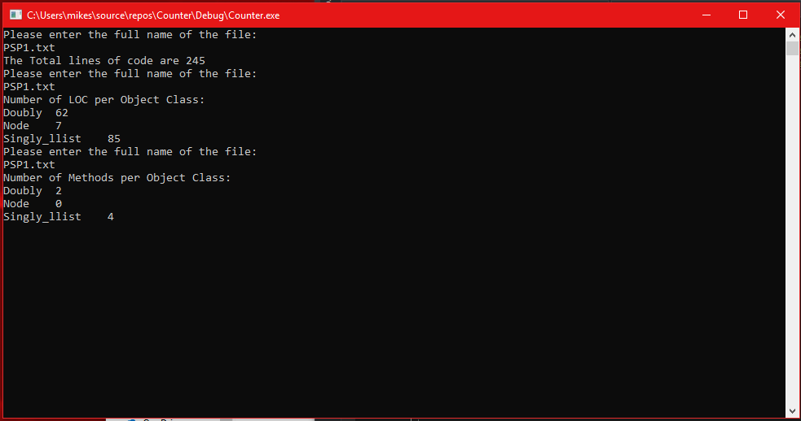

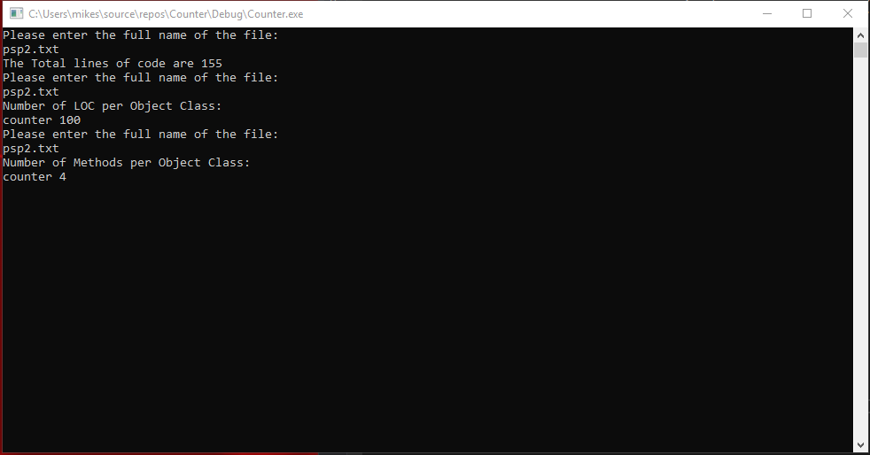

|  |  |  |  |  |
| --- | --- | --- | --- | --- |
| Program Number | Object Name | Number of Methods | Obect LOC | Total Program LOC |
| PSP1 | Doubly | 2 | 62 |  |
|  | Node | 0 | 7 |  |
|  | Singly_llist | 4 | 85 |  |
|  |  |  |  | 245 |
| PSP2 | counter | 4 | 100 |  |
|  |  |  |  | 155 |